The MorningStar Home
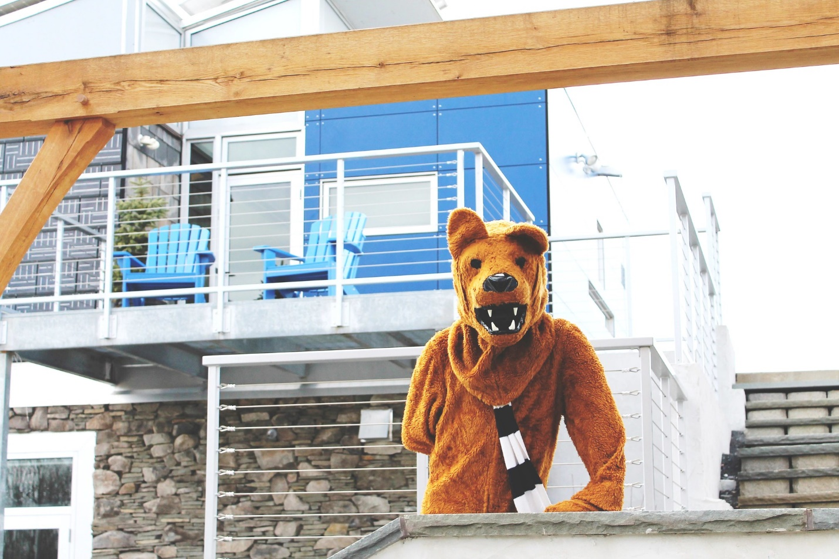

Key Take Aways:
- Built for the 2007 Solar Decathlon by more than 800 students and faculty
- Placed 4th beating notable universities such as MIT, and CMU
- Net positive renewable-energy powered home
- Utilizes both passive and direct solar energy to maximize efficiency
- Currently used today for research and education on sustainability
- The MorningStar also includes Rain-catchers, Geothermal heating, and a Solar-powered car port
- Three main principles: Thinking Locally, Holistic Sustainability, and Passive Solutions
- https://pennstateoffice365.sharepoint.com/sites/SustainabilityExperienceCenter/Shared%20Documents/Forms/AllItems.aspx?id=%2Fsites%2FSustainabilityExperienceCenter%2FShared%20Documents%2FArchive%2FCFS&p=true&originalPath=aHR0cHM6Ly9wZW5uc3RhdGVvZmZpY2UzNjUuc2hhcmVwb2ludC5jb20vOmY6L3MvU3VzdGFpbmFiaWxpdHlFeHBlcmllbmNlQ2VudGVyL0VpaFUwU2xOODZ4SnJORTFTZEpsYncwQmYzVEMzU0k5bmM0OF80ejdJaENRWlE_cnRpbWU9ZTZMS3JrY3UyRWc
Introduction
The MorningStar home was designed and built by students for the 2007 Solar Decathlon. The Solar Decathlon is a collegiate competition sponsored by the U.S. Department of Energy. This biennial competition challenges students to design and build innovative housing solutions through a total of ten contests based on architectural design, innovation, energy efficiency, and smart energy production. The mission of the Solar Decathlon is to raise awareness on clean energy and prepare students for entrance into the clean energy workforce. A core group of 30 students of the Solar Decathlon club began designing the MorningStar home in 2005, and with the help of nearly 800 students from various academic backgrounds (architectural engineering, mechanical engineering, aerospace engineering, business, communications, etc.), the MorningStar home was constructed and ready to compete at the 2007 Solar Decathlon.
The Penn State team specialized with the market viability contest at the Solar Decathlon. With the goal of making solar homes more marketable, the team designed and built two different homes for two different climates and markets. The “racecar” model MorningStar home (as pictured) is located at the Sustainable Experience Center, and it serves as a renewable energy research lab and educational classroom. The sister home, MorningStar Montana is located on the Northern Cheyenne Reservation. This sister home is more affordable deems to show the feasibility of sustainable architecture no matter the setting.
The competition MorningStar home costed about $350,000. The sister model in Montana which was built after the competition is larger (1,100 sq ft with 2 bedrooms) and only costed about $150,000. The comparison between these two models is a testament to the improvements that can be made through intelligent design and by analyzing the results of the original house. By collecting data on what systems operated best in unison, it can be decided what components of the house are absolutely crucial to maintain the desired sustainability goals, while minimizing cost. The MorningStar has a building management system that periodically keeps track of how much energy is being used, where that energy is coming from, and where the energy is going. Lessons derived from this data led to the improvements that allowed the second house to be built larger and for a lower cost.
19 institutions competed in the 2007 Solar Decathlon. Throughout the week, Morningstar did well taking 3rd place in the decathlon. It was the last event, hosting a dinner party for fellow competitors, that bumped Penn State down into 4th place. Instead of taking leftovers back to their hotels, students had put their warm food in the refrigerator of MorningStar, forcing the fridge to consume more energy to cool down the food. This process consumed just enough energy to lose 3rd place by just about 4 points. Even still, for the first time competing,4th place was not bad especially when you consider the company they were keeping. Penn State was able to beat out schools such as M.I.T., Cornell, Carnegie Mellon, and the University of Colorado. 1st place went to the German University of Darmstadt, the University of Maryland came in 2nd place, and the University of Santa Clara came in 3rd place.

The Home
The project team implemented three key values in developing the home: Thinking Locally, Homeowner interactions, and Passive/Unique solutions
Direct solar solutions are utilized to make the home aggressively efficient. Solar panels or photovoltaic cells are present on the roof, and a portion of the sidings of the home to generate electricity. these cells work by allowing photons or tiny light particles to knock off electrons from atoms generating electrical current that can be used by the home. The home is oriented southward to obtain maximum sun coverage thus boosting the energy production of the solar panels.
Complete with a bedroom, living and dining spaces, and a fully functioning kitchen and bathroom, the interior of the home is a grand total of 800 square feet. Much thought was put into the design to maximize both energy efficiency and space. One of the easiest things to do when creating the appearance of more space is to have lofted or open ceilings. While it helps to solve the problem of feeling cramped in smaller spaces, it also means you have more air to heat. Another technique implemented to ensure that the building felt roomy enough is the use of many windows and skylights. The walls are almost half comprised of large, floor to ceiling windows. These windows bring the light of the surrounding environment into the Morningstar, while also adding to the illusion that the living space extends beyond the walls of the home itself. As with the high ceiling, the implementation of windows makes it more difficult to keep the house warm because windows are thinner than the wall. To overcome this, efficient and well insulated double-paned windows were chosen. These windows make use of the greenhouse effect to trap heat from the sunlight while using the insulation to prevent the heat from escaping. This greatly improves the MorningStar’s energy efficiency even in the coldest Central Pennsylvania winters.
Perhaps most the most innovative implementations of indirect solar are the milk jugs. These milk bottles get filled with water, hung from the sliding racks, and placed in front of the windows to catch Sun rays. The rays then heat the water, which has a very high heat capacity making it great at retaining heat, As the sun goes down and the temperature within the home drop, the milk bottles become a source of radiant heat stabilizing the air temperature of the home. The milk bottle wall was seemingly the most popular and distinctive feature among Decathalon spectators.
In addition to passive solar, students confronted the task of heating the home through the installation of radiant floor heating because when your feet are warm, typically the rest of your body will feel comfortably warm, resulting in less energy being used to heat the air. A geothermal well is also implemented to equilibrate the temperature inside with the average underground temperature of around 60 degrees F. Therefore, if the outdoor temperature is colder than it is underground, the home will heat up, and if the temperature underground is colder than it is outdoors, then the home will cool down.
Students also designed the home to be a versatile and included features such as tuck-away closets, a combined dresser-credenza that slides to make give room as needed, as well as room dividers to give one the option to divide or define the space. These clever additions make the house easier to use, and make it feel like a larger space. The movement of the dresser essentially adds 10ft^2 to the floorplan because the space in that area can be used in two entirely different ways. The hide away walls allow visitors to separate and use space at their convenience, but do not permanently constrict the space. When they are not in use, they can be hidden away, leaving the floorplan open and feeling larger. The tuck-away closets serve a similar purpose. They include ample storage space, but when not in use they appear to par a part of the building itself.
Thinking locally is a crucial part of sustainability. Local thought when sourcing materials reduces overall carbon footprint, enriches the local economy, and can lower overall the cost of building as a whole. By sourcing things locally, builders can avoid shipping materials over a long distance, which carries a high cost both in terms of carbon emissions and monetarily. In addition, buildings should be designed with their specific locale in mind. A well-designed building is best suited for the environment that it exists in. The MorningStar was built with the specific weather patterns of Central Pennsylvania in mind.
The siding of the MorningStar home was salvaged from Carlisle, PA. These slate shingles used to exist on the roof of a barn that was torn down. The slate shingles had existed on the barn for 50 years and are expected to spend another 50 on the Morningstar. Salvaging materials for use greatly reduces the carbon footprint of the house because there were no carbon emissions resulting from the production of new materials. The slate only involved carbon emissions from transportation, which is minimized due to local sourcing. In addition, the salvaged slate is saved from being thrown out, and taking up limited landfill space. The slate also has thermal properties that are well suited to our needs with the solar home. The slate absorbs heat energy from sunlight.
With these three values: Thinking Locally, Homeowner interactions, and Passive/Unique solutions, the MorningStar symbolizes the sustainable future of living around the world. It is tangible proof that eco-friendly housing is not only feasible, but it can be both luxurious and affordable.

