The Community Garden
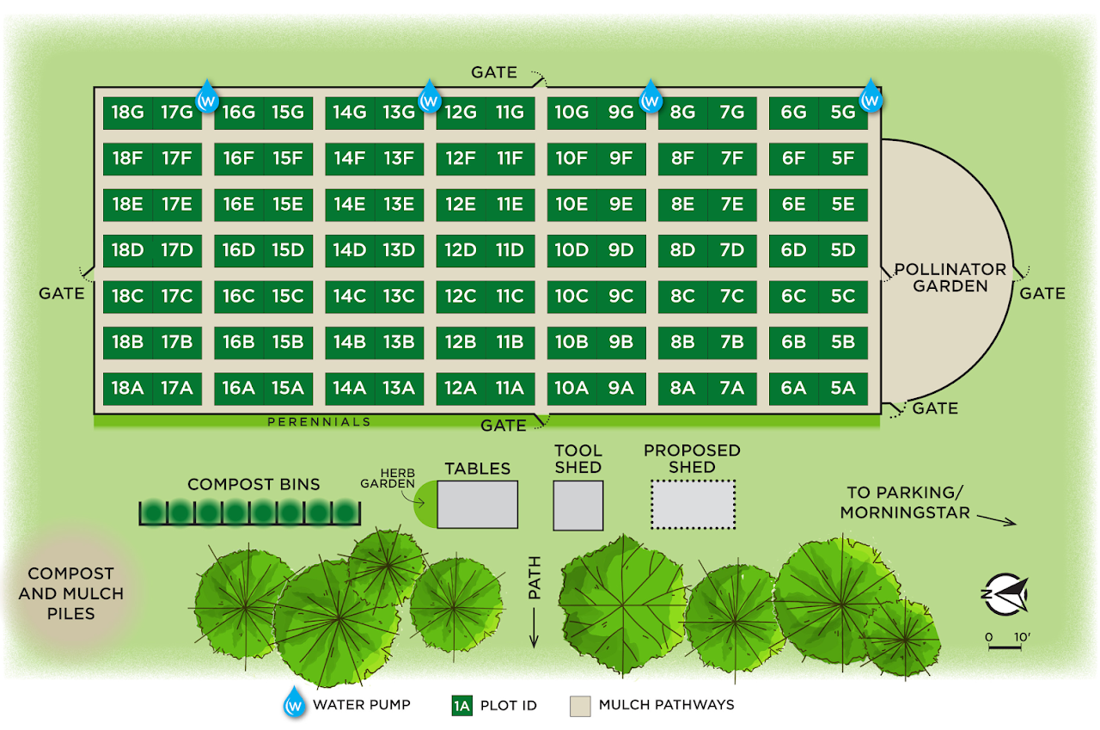

Key Take Aways:
- Faculty Representative: Mary Barbercheck (meb34@psu.edu)
- A student-run garden since 2009
- Anyone can apply for one of the 96 plots
- Classes and events for the public
- Pollinator Garden developed in collaboration with the Master Gardener Program and Center for Pollinator Research

Video Script:
Founded in 2009, the Community Garden at Penn State is a student-run organization that has been drawing in members of the State College community for more than a decade. The garden is both a student run organization and a part of the Sustainability Institute. It is an easily accessible community space that invites individuals to take stewardship of a garden of their own, connect with others, and participate in experiential learning. Members run along a spectrum, from novice to veteran gardeners. This family-friendly space provides excellent opportunities for all to understand how everything is connected and bond over monthly events and activities.
There are ninety-six 10’x15’ plots and gardeners have access to a communal tool shed, compost system, recently installed water, and rototillers. In addition, gardening workshops, and public events are held numerous times in the warmer seasons. Members are required to come out for two garden workdays per year, during which members work together to uplift and maintain the garden as a whole as opposed to simply working their own plots. Being a student-run organization, it is mandatory that half of the plots are reserved for students. The community garden is also a great place for post-grads to meet one other and form bonds over gardening.
A pollinator garden is located on the west end which resulted from a grant a few years ago. Master Gardeners at Tudek Park aided in the selection of the specific pollinator plants. In addition, a perennial border is present along the perimeter of the garden. Members also have an opportunity to practice philanthropy by donating fresh produce through an initiative started by Center Moves. As of now, donations are given to a women’s resource center, and the Community Garden at Penn State is one of several local community gardens participating in this initiative.

For more information or to apply for a plot, visit www.psugarden.org

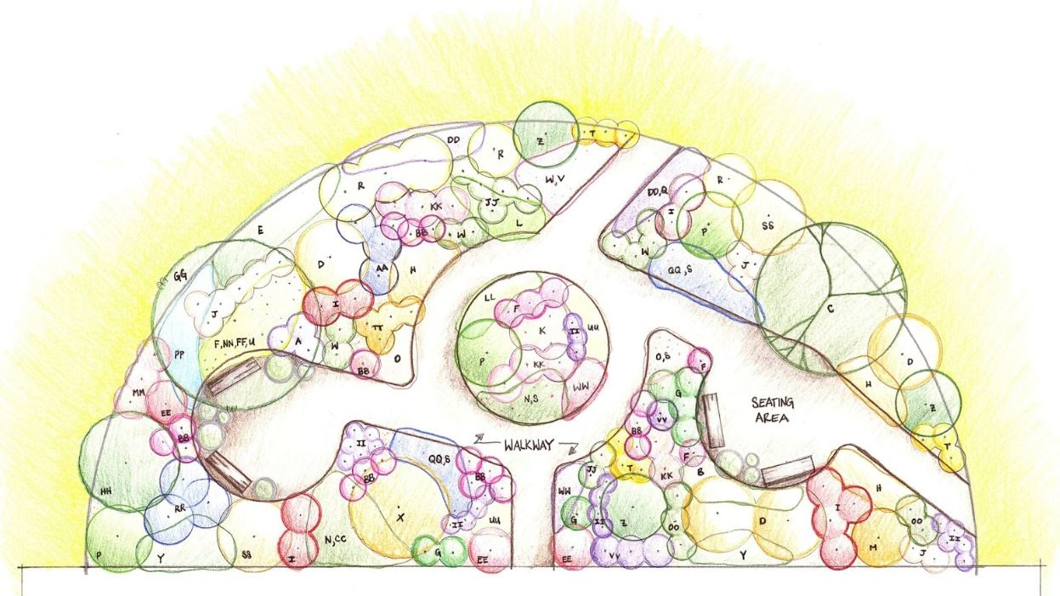
Final plan of the pollinator garden with 50 native plant species
