SEC Virtual Tour - Sweet Gum Trees
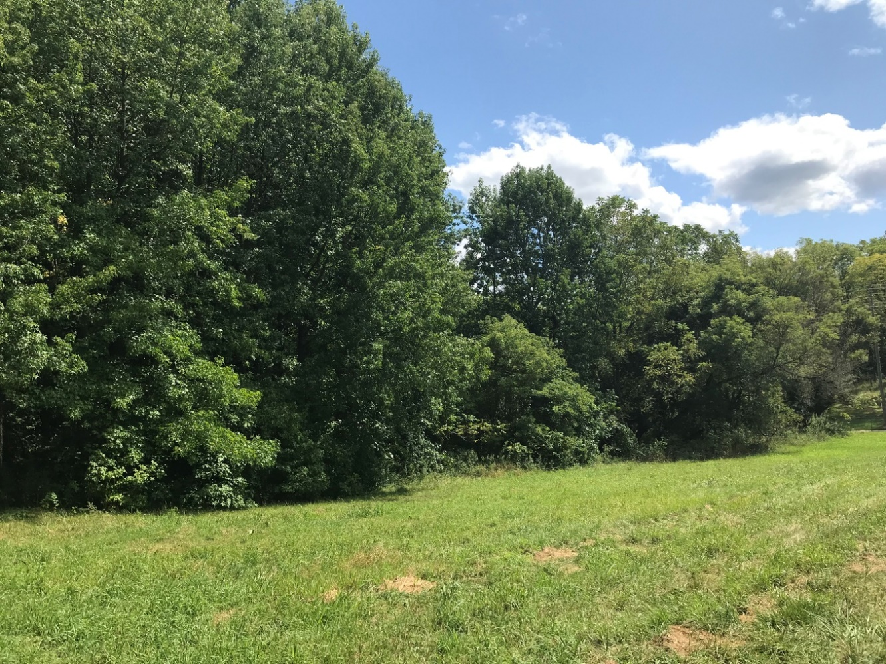

Quick Facts:
- Project leader: Dr. Jesse Lasky (jrl35@psu.edu)
- Sweet Gums are a more southern species in the United States
- The research addresses plants' ability to adapt to their environments and in turn this information can be used to predict responses to climate change
- Trees need to continue serving as carbon sinks, but climate change will likely impair their ability to do so

The Sweet Gum Trees were planted during the same time as the Black Walnuts by Kim Steiner. Sweet Gum Trees are not native to our area but have still been present in our state for a while now. It is possible for its range, however, to reach further North due to rising temperatures as a result of climate change. Overall, this study seeks to address the genetics, traits, and ability of these trees to adapt to their environment. Since trees are an important part of the carbon cycle, it is important to have an understanding of this information because it will help us predict responses to climate change. Jesse Lasky is also involved with this project as the main researcher and wishes to conduct more research on these specific trees, because they are valuable for ecological research. It would also be helpful to use these trees to study how varying genotypes may be adapted to similar environments while the climate is changing.
In the future, it would be ideal to have road access to these trees and keep up with maintenance such as keeping pathways clear of poison ivy. It would also be helpful to mark each tree with their original location and use their cores to show during which climate the trees did or did not do well. Continuing on with this research is important because people will be able to understand not only how their own actions have an impact on their environment but also the effect climate change has on organisms. Bringing the Sweet Gum Trees to Penn State is significant because they may be able to handle rising temperatures due to climate change. Overall, this research is not commonly seen, so we are lucky to be able to have these trees for research, classes, and for the general public.

