Sustainable Experience Center’s
Skystream 3.7 Wind Turbine
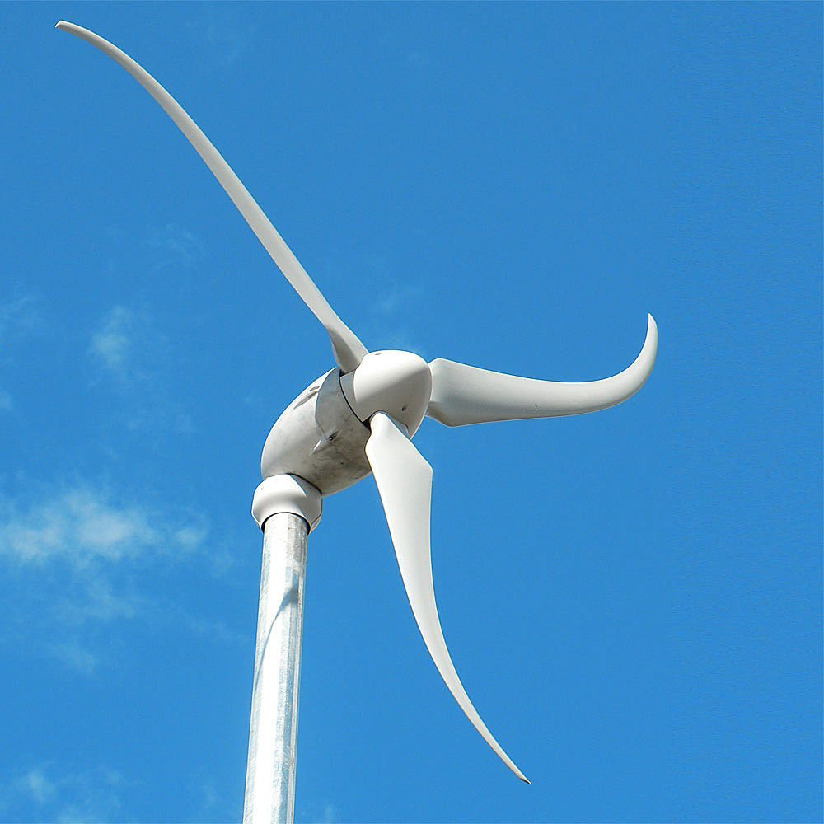
Quick Facts:
^{[1]} Image Source: Xzeres (Manufacturer)
- Project Lead: Dr. Susan Stewart
- Grid connected to the MorningStar
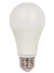
- Turbine was Engineered & Manufactured in the USA
- 2.1 kW Peak Power Rating (About 140 LED bulbs outputting 1600 Lumens)
- 3-bladed, horizontal axis, downwind design (Rotor is behind the tower as the wind approaches, allowing the turbine to seek the wind direction)

Video Script:
We are now at the Skystream turbine, located next to the MorningStar, and it is under Dr. Susan Stewart’s direction. This turbine model was designed with support of the Department of Energy’s National Renewable Energy Laboratory, the Skystream turbine was both manufactured and engineered in the USA. This particular model is meant for small wind applications, such as providing power to a residence. Installed in July 2011, as a part of the PA Wind for Schools Program, the tower is 70 feet tall and is a horizontal axis – downwind machine with an internal data acquisition system. A series of three anemometers, which measure wind speed, are installed at various levels and orientations to catch the variation in wind speed with height. The tower also has a wind direction sensor. As we take a look at the 6 ft blades, notice the subtle “S” shape of the fiberglass blades engineered for noise reduction. The Skystream turbine can produce approximately 5,400 kWh/yr in a very windy (i.e. 6 m/s or ~13 mph annual average wind speed), wide open location. This is about half the energy requirement of a typical PA home (10,284 kWh/yr). At this site on Penn State’s University Park campus, surrounded by trees and two large stadiums, the machine is producing about 1,000 kilowatt hours of energy per year and this electricity goes to the MorningStar house and the Penn State grid. In the equipment room of the MorningStar classroom, a computer stores the data collected from the Skystream turbine. While the energy produced from this machine does not greatly impact the PSU campus, the acquired data can be used for numerous areas of research including wind resource assessment, turbulence impacts on wind power production, microclimates, and as a part of studies on the hybrid residential renewable energy system, as examples. Another Skystream turbine is also installed at the nearby Mount Nittany Elementary School, and the data from both turbines can be compared with one another via the OpenEI Wind for Schools Portal.
The installation was initially funded through a state grant connected with the MorningStar and it was tied to Penn State’s application to join the National Renewable Energy Laboratory’s (NREL) Wind for Schools program. NREL has provided funding to Penn State’s Aerospace Engineering Department and the Centre for Science and the Schools to run the PA Wind for Schools Program since 2010. This program annually provides PA K-12 educators with Teacher Professional Development Workshops in wind energy and also hosts an annual Middle School and High School level KidWind competition each spring. Several Aerospace Engineering students have also conducted their graduate research using the data acquired from this facility. Students have created several theses and have earned jobs because of the wind experience they gained here. Having turbines on campus creates opportunities to make wind energy tangible, and it illustrates that sustainability is achievable.

Sources Links:
^{[1]} https://www.xzeres.com/?page_id=351

