SEC Virtual Tour - Black Walnut Provenance Study
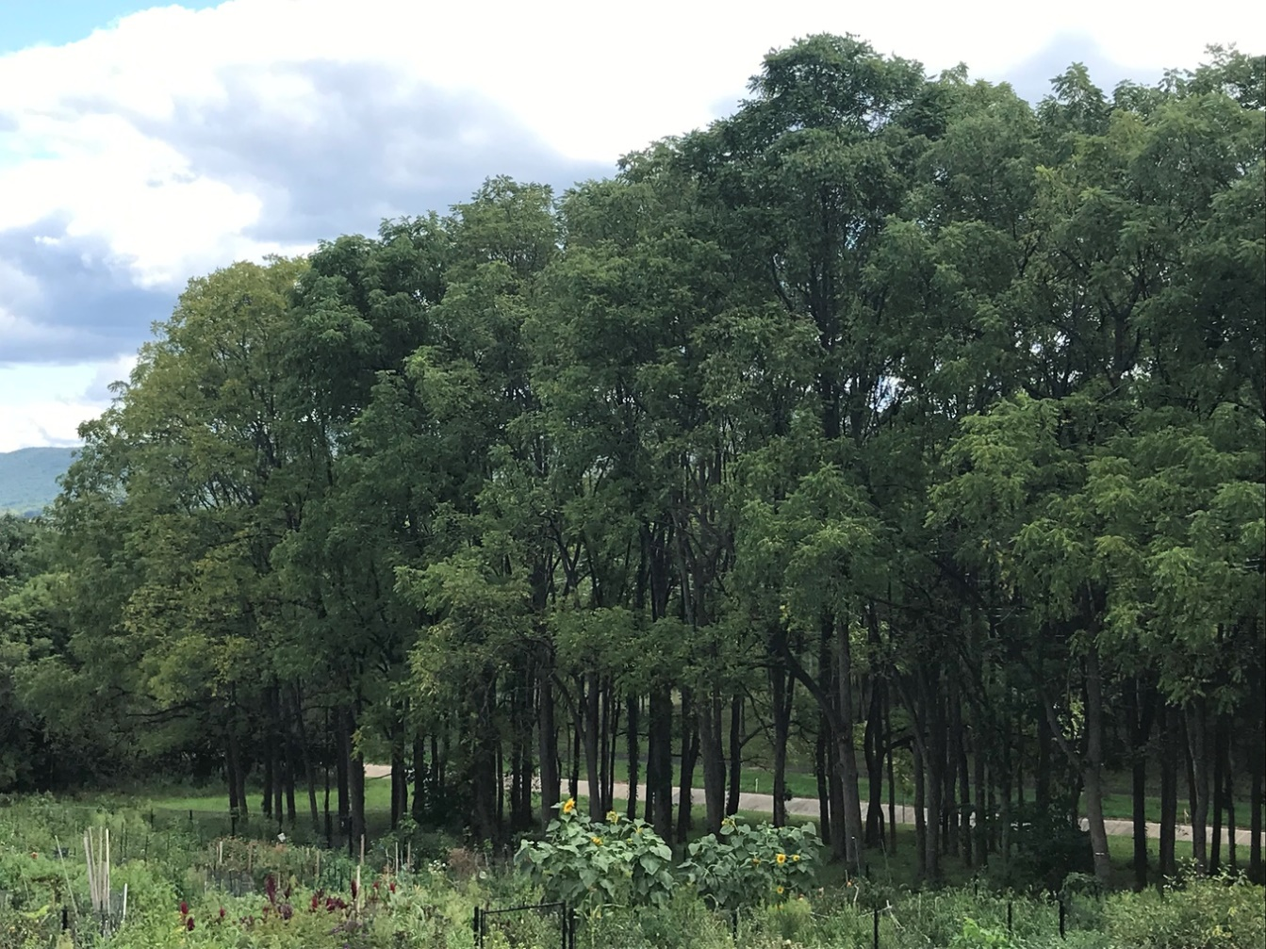

Quick Facts:
- Project leader: Dr. Laura Leites (lpl3@psu.edu)
- Provides opportunities for undergraduate and graduate research
- Trees originally planted back in the 1980's by Kim Steiner, Director of the Arboretum
- Study addresses how trees adapt to the environment and how climate affects them
- Shows the importance of seed selection for restoration and reforestation efforts, as well as the impacts of climate change

The Black Walnut Tree provenance study is located past the Morningstar Solar Home on both sides of the concrete channel. In 1980, Kim Steiner established the range-wide study and is now directed by Laura Leites. Each of the rows of trees is from exactly one provenance of the natural range of Black Walnuts and the differences between them are primarily genetic. This study seeks to address their adaptation to climate in black walnut and broadleaf deciduous forest tree species; for example, trees in colder regions will have a much shorter growing season than those in warmer regions. Essentially, during restoration or reforestation, it depicts not only the importance of seed selection but also the impacts of climate change on trees.
When the study originally started, Kim Steiner actively measured the trees’ height, diameter, and their survival for decades until her research was eventually passed onto Laura Leites. She is currently studying the diameter growth from the past 40 years in order to view how each of the provenances are different in responding to climate. As part of the project, they are also viewing the interacting genes and competition between each of the trees based on data on aspects such as diameter, tree cores, crown diameter, and height. Penn State additionally has a small team of approved drone flyers. Footage from these drones may be utilized to measure senescence during the fall and growing of the leaves during the spring which reveals the length of the trees’ growing seasons. Since this test is a long-term, valuable study, the one issue is ensuring that nothing affects the provenance test’s integrity. Ideally, it is our hope to utilize these trees as a demonstration site for undergraduates to potentially participate in smaller projects during their college career.

